History Dept. Teach-In

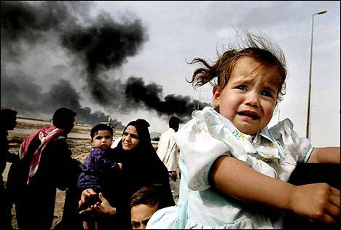
New York Times Photo

Iraq: Anatomy of a Crisis
Tues. April 8, 12:45-2:15
Room 5-160
Participants include Professors Ervand Abrahamian, Thomas Heinrich, Katherine Pence


Baruch College joins dozens of Colleges and Universities Nation-wide, United in Staging Teach-ins about the Implications of War

